Contents
Unit tests using GitHub Copilot 2
Visual Studio Code support for unit tests 2
Create a test project using the Command Palette 2
Unit testing workflow with GitHub Copilot 2
Generate unit tests with the GitHub Copilot Chat view 3
Set up a testing framework with /setupTests 7
Generate tests with /tests 8
To generate tests for an entire file 8
To generate tests for a specific method or block of code 9
Generate tests with a natural-language prompt 9
Add context to prompts 9
Personalize test generation with custom instructions 10
Plan and automate test workflows using the Plan and Agent modes 11
Use the Plan Agent to design a test strategy 12
How Plan Mode works 12
Use the Agent to automate test workflows 13
Decide when to use Plan, Agent, or both 14
Updating Test case file using Ghost Text 14
Fix failing tests from Test Explorer 15
Fix failing tests with /fixTestFailure 15
Agent monitor and fix failures automatically 16
Choose the right tool for the job 16

Unit tests using GitHub Copilot
To generate unit tests with GitHub Copilot, the project needs a working test framework and a way to run tests inside Visual Studio Code.

Visual Studio Code support for unit tests
To create and run C# unit tests in Visual Studio Code, we need:
- The .NET 8.0 SDK or later.
- The C# Dev Kit extension for Visual Studio Code.
- A test framework package added to the project

The C# Dev Kit supports the following test frameworks:
- xUnit
- NUnit
- MSTest

Create a test project using the Command Palette
- Press the Ctrl + Shift + P keys (Windows/Linux) or Cmd + Shift + P (macOS).
- Open the View menu, and then select Command Palette.
- Open the Solution Explorer view, right-click the solution folder, and then select New Project. This option opens the Command Palette with the .NET: New Project...
When supported framework is xUnit : select .NET: New Project..., select xUnit Test Project and add reference to the project
When supported framework is NUnit : select .NET: New Project..., select NUnit3 Test Project and add reference to the project
When supported framework is MSTest : select .NET: New Project..., select MSTest Test Project and add reference to the project

Unit testing workflow with GitHub Copilot
Visual Studio Code with GitHub Copilot, the unit testing process breaks down into three stages:
Stage 1 : Set up the environment- creating test project as per framework available and adding reference
Stage 2 : Generate test code: Use GitHub Copilot in the Chat view to generate unit tests for the application
Stage 3 : Run and maintain tests: Use Test Explorer and the C# Dev Kit to run tests, then use GitHub Copilot to extend coverage and fix failing tests.

Generate unit tests with the GitHub Copilot Chat view
Chat view in Visual Studio Code is the primary place to generate unit tests with GitHub Copilot.
Test cases are generated file or selection
Unit tests can be generated using Agent Mode and Ask Mode
Plan Mode : Plan Mode Copilot drafts a plan like:
- Identify testable modules
- Create test files
- Add mocks
- Add coverage check
Note: Plan mode not available in GitHub Copilot Free account
Agent Mode: writes test cases directly in test file
Ask mode is used beforehand to explore testing options without making any file changes
Use Ask mode when:
- Compare candidate test cases for a complex method before committing to a structure.
- Identify edge cases and boundary conditions worth covering.
- Get a recommendation for a test framework or assertion style.
- See an example test in chat without writing it to disk.

Chat view provides 3 configuration choices:
- Agent Target - Where the agent runs. Select Local to run the agent interactively in the editor with full access to workspace, tools, and models
- Agent: The role the AI takes for the session. The built-in local agents are Ask, Plan, and Agent.
- Permission level - How much autonomy the agent has when invoking tools and terminal commands. Options are Default Approvals, Bypass Approvals, and Autopilot.

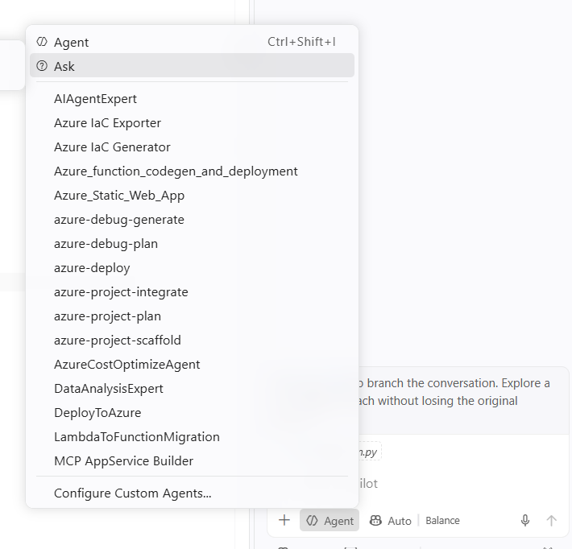
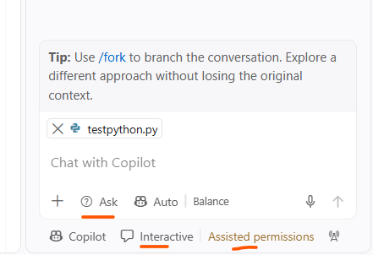
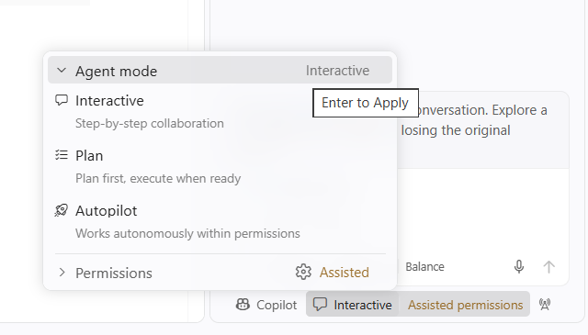
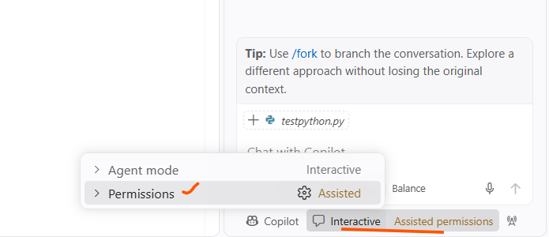
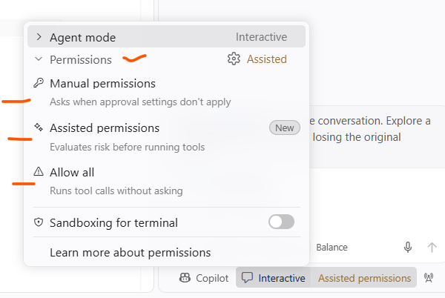

For unit test generation, the recommended starting point is the Agent with Default Approvals.
Use Ask mode to explore testing options first
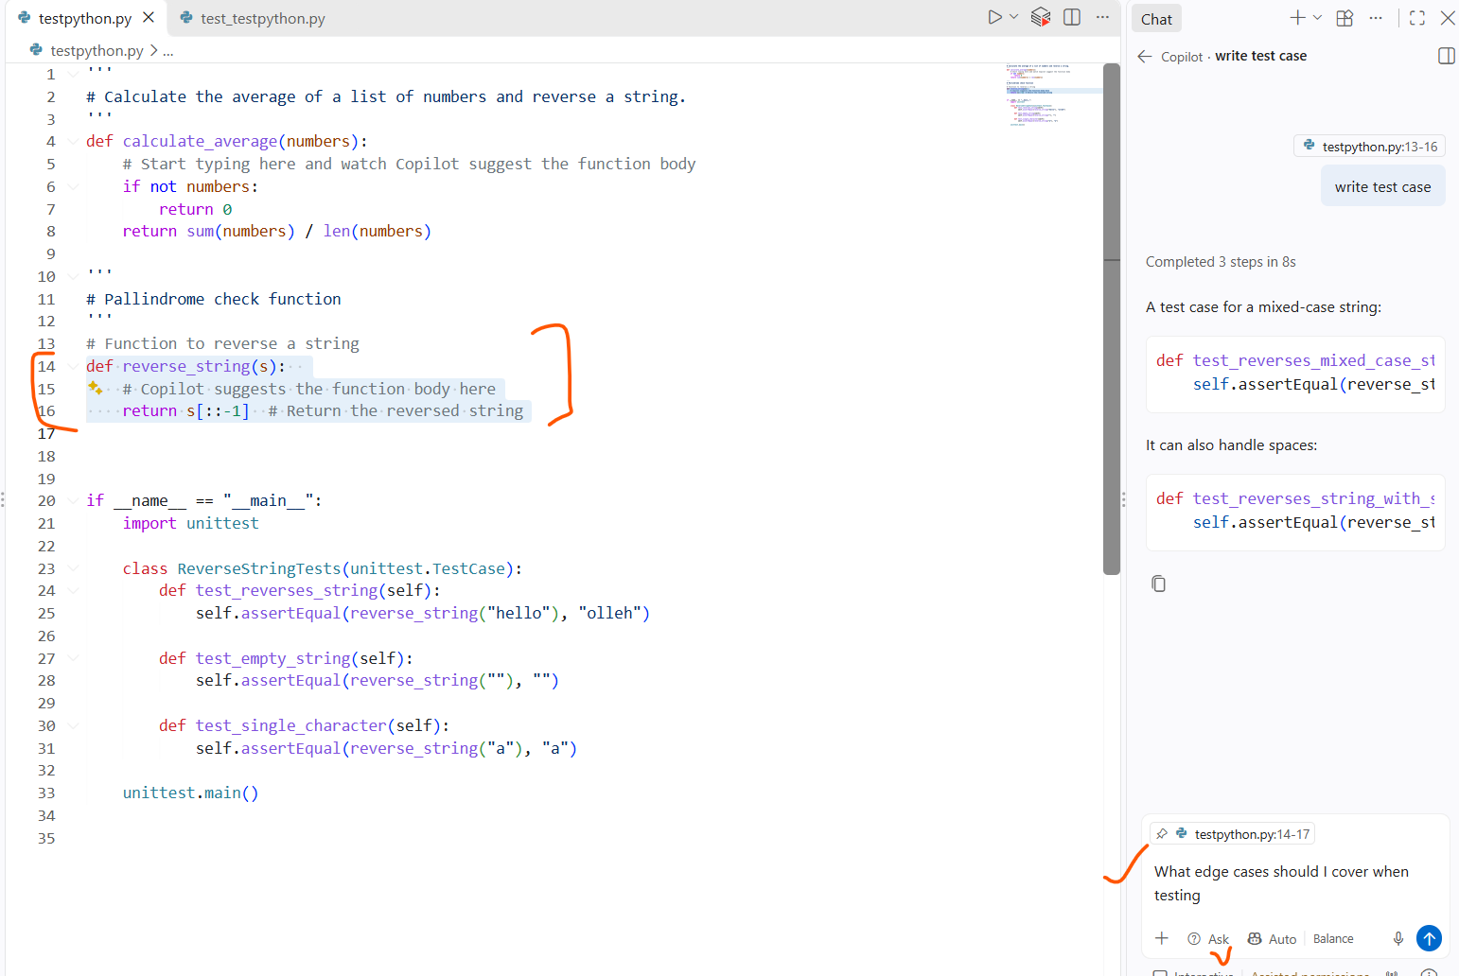
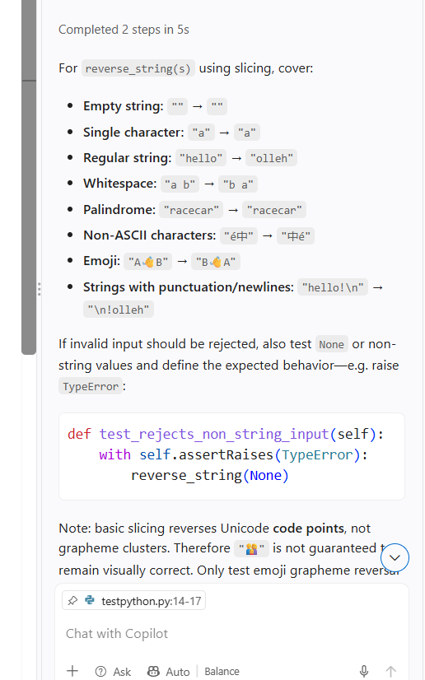

Switch to Agent mode, once decided, now at this time, the file will updated with required test case
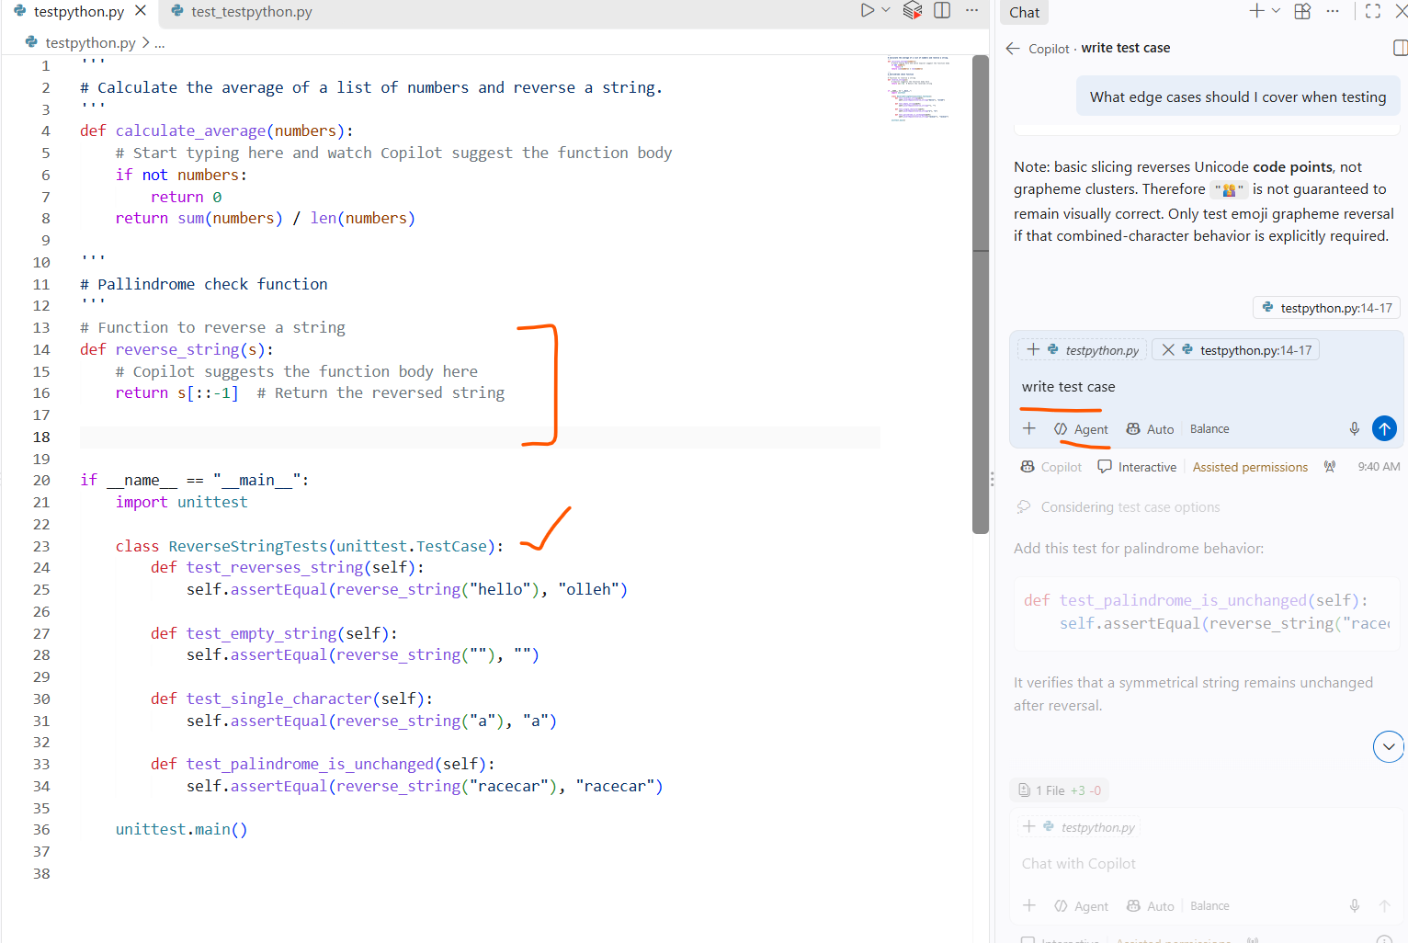

Set up a testing framework with /setupTests
GitHub Copilot recommend test framework and walk through configuration step
The /setupTests slash command works in any agent, but Agent mode can also install packages and create the test project
- Open the Chat view and select Agent from the agent picker.
- Enter the /setupTests command in the chat input field.
- Confirm the tool invocations and terminal commands the Agent suggests to install packages, scaffold the test project, and recommend Visual Studio Code testing extensions.
/setupTests is most useful when starting a new test project or onboarding a project that doesn't yet include tests.
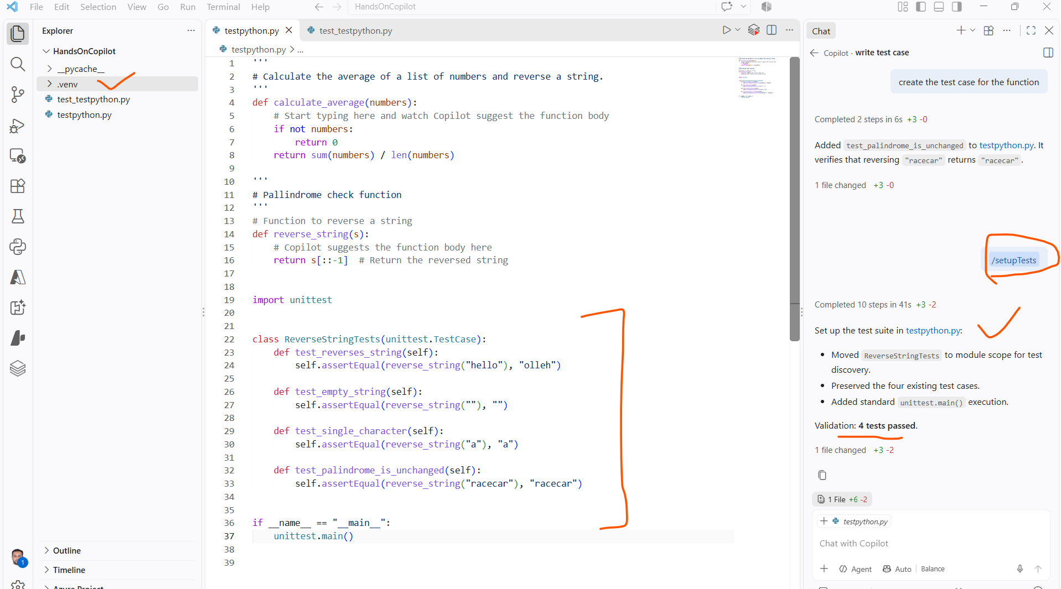

Generate tests with /tests
The /tests slash command generates unit tests for the code that's currently active in the editor
In Agent mode, the generated tests are written directly into an appropriate test file. GitHub Copilot detects the existing test framework and coding style and produces tests that match.
Note: /tests does not work for free github copilot account

To generate tests for an entire file
- Open the application code file needed to test
- Open the Chat view and confirm that Agent is selected.
- In the chat input field, enter /tests followed by any additional guidance.
For example: /tests Generate unit tests for the methods in this file. Include success, failure, and edge cases.
- Confirm the tool invocations the Agent uses to read context, write the tests, and (optionally) run them.
- Review the changes the Agent applied.
The Agent appends tests to an existing test file when one is available, or creates a new test file in the appropriate location. The diff appears in the editor so you can verify each change.
- Select Keep or Undo to accept or discard the changes.

To generate tests for a specific method or block of code
- Open the application code file.
- Select the method or block you want to test.
- In the Chat view, enter /tests followed by guidance that references the selection.
For example: /tests Generate unit tests for the selected method. Validate both success and failure, and include edge cases.
- Review and keep or discard the resulting changes.

Generate tests with a natural-language prompt
Agent generates tests from natural-language prompts using context.
Examples:
- Generate xUnit tests for the methods in this file and add them to the Calculator.Tests project
- Write unit tests for the CalculateDiscount method, including edge cases for negative values and zero. Run the tests after writing them
- Create integration tests for the data access layer in this module

Add context to prompts
Quality of the generated tests depends on the context provided
Use one or more of the following options to attach context to a Chat view prompt:
- Add Context button: Open a Quick Pick to add files, folders, symbols, or the current editor selection.
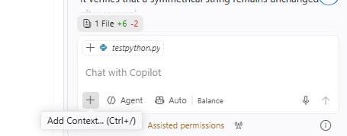
- Drag and drop: Drag files from the Explorer view, or drag an editor tab, onto the Chat view to attach the contents.
- # mentions: Type # followed by a file, folder, or symbol name to add it as context. Use #selection to attach the current editor selection, or #codebase to let GitHub Copilot search the workspace for relevant context.
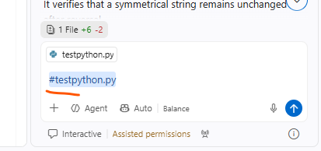
- External files: Open markdown files in the editor and attach them through Add Context. The Agent uses the content to shape the generated tests.

Personalize test generation with custom instructions
If the organization has specific testing requirements, customize GitHub Copilot to generates tests to the output matches as per standards.
Custom instructions are :
Specify preferred testing frameworks (for example, xUnit instead of NUnit).
- Define naming conventions for test classes and methods.
- Set code structure preferences such as the Arrange-Act-Assert pattern.
- Request specific test patterns, such as parameterized tests for boundary values.

Store custom instructions in a *.instructions.md file in workspace. Use the applyTo metadata field to apply the instructions only to test files. For example, an applyTo: tests/** value scopes the instructions to files in the tests/ directory. Sharing the file in source control gives every developer on the team the same testing context.
place at the top of *.instructions.md file, inside a metadata block.
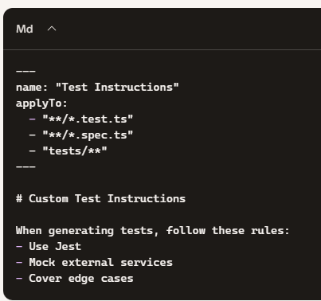

Plan and automate test workflows using the Plan and Agent modes
Larger testing tasks need more structure:
- deciding what to test
- scaffolding a test project
- generating tests across several files
- running the resulting suite
Use Plan mode to design a test strategy before any code is written, then hand the approved plan to the Agent for autonomous, multi-step implementation.
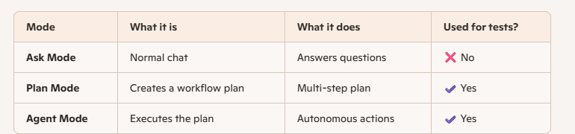

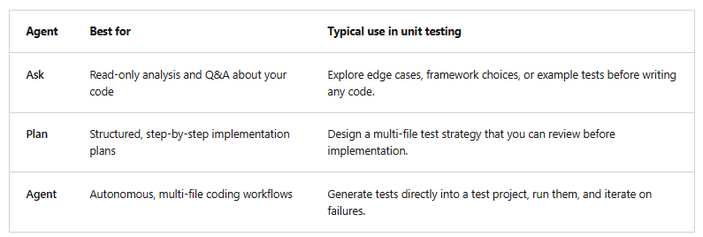
Choose an agent by selecting it from the agent picker in the Chat view. You can switch agents at any time during a session.
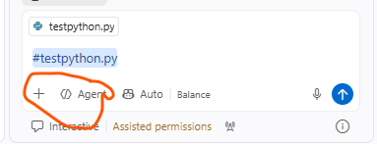

Use the Plan Agent to design a test strategy
The Plan agent produces a detailed implementation plan before any code is written
The agent researches task, asks clarifying questions, and proposes a step-by-step plan that can reviewed, refined, and hand off to the Agent.
To plan a set of unit tests:
- Open the file or files that contain the code require testing
- Open the Chat view and select Plan from the agent picker. Alternatively, type /plan followed by task description.
- Enter a prompt that describes the tests required to be created.
For example:
I need unit tests for the methods in the Calculator class. Use xUnit. Include tests for success, failure, and boundary conditions. Place the new tests in the Calculator.Tests project.
- Answer any clarifying questions.
The Plan agent might ask about test framework preferences, naming conventions, or how to handle dependencies before drafting the plan.
- Review the proposed plan.
The plan typically includes a high-level summary, a breakdown of steps, verification steps for running the tests, and documented decisions. Iterate with the Plan agent until the plan reflects what is required to build.
- Hand off the plan for implementation.
When the plan is final, select the option to start implementation. Implement the plan in the same chat session, or start a background or cloud session to work on the implementation autonomously. Also open the plan in the editor for further review.
The Plan agent is especially useful when testing task spans multiple files, requires new test classes or fixtures, or needs to align with team conventions that aren't already captured in instructions.

How Plan Mode works
Step 1 — Open Copilot Chat
You will now see a mode selector at the top:
Ask
Plan
Agent
✔️ Step 2 — choose Plan
Copilot will ask:

“What would you like me to plan?”
You give a high‑level instruction, e.g.: “Create a full test workflow for this project.”
✔️ Step 3 — Copilot generates a plan
You approve or edit the plan
You can: Approve the plan| Reject steps |Add steps |Remove steps
Step 5 — You click Run as Agent
This hands the plan over to Agent Mode.

Use the Agent to automate test workflows
The Agent automates multi-step tasks across the workspace. For unit testing, use the Agent to scaffold a test project, create test files, run the resulting tests, generate test reports, or fix issues that surface during a test run.
To use the Agent to create and run unit tests:
- Open the file that contains the code required to be tested.
- Open the Chat view and select Agent from the agent picker.
- Let the Agent determine the context.
When we use the Agent, GitHub Copilot automatically identifies the relevant files. Also attach additional context with the Add Context button or by dragging files into the Chat view.
- Optionally, select the Tools icon to choose the tools the Agent is allowed to use for the task.
Useful tools for testing tasks include the file editing tools, the terminal tool for running dotnet test, and any extension-provided test tools.
- Enter a prompt that defines the task. For example:
Ensure that a suitable unit test project is prepared for the selected code file. Create a test file in the unit test project that includes unit tests for all methods in the selected file. Unit tests should be written in C# and use the xUnit framework. Run the tests to ensure expected results.
- Monitor the Agent as it works.
  - Confirm or reject the tool invocations and terminal commands the Agent suggests. For example, confirm the command to run the tests or to generate a test report.
  - Interrupt the Agent if needed to change the context, switch tools, or adjust the scope of the task.
- Review the files the Agent created or updated, and then keep or discard the changes.
Use follow-up prompts to refine specific tests if necessary.
Steps:
1. Open your code file
Example: MyClass.cs
2. Open Copilot Chat
Select Plan.
3. Ask for a test workflow
Example: “Create a test project, generate xUnit tests for all methods, run tests, fix failures.”
4. Copilot generates a plan
You approve it.
5. Switch to Agent Mode
Copilot starts executing the plan.
6. Agent runs tools
You approve each action.
7. Agent finishes
You review the created test files.

Decide when to use Plan, Agent, or both
Use the following guidance to choose between the agents:
- Use the Plan agent first when the testing work involves ambiguity, multiple files, or team conventions that need to be confirmed. The plan becomes a contract , review before any code is written.
- Use the Agent directly when the task is well defined and want GitHub Copilot to scaffold, generate, and run tests without an intermediate planning step.
- Use Plan and then hand off to Agent when required a reviewable plan plus autonomous implementation. This combination gives the most control over scope while still automating the work.

Updating Test case file using Ghost Text
Ghost text suggestions add additional test cases inside the file you're editing
Test Explorer and the /fixTestFailure slash command help diagnose and fix failing tests.
Together, these features close the loop on the unit testing workflow that started in the Chat view.

To extend a test file with ghost text:
- Open the test file that contains at least one or two complete test cases.
- Position the cursor at the end of the last test case and press Enter to start a new line.
- Start typing a new test method or write a descriptive comment such as // Test that ProcessOrder throws when the order total is negative.
GitHub Copilot displays a ghost text suggestion that completes the test method based on the surrounding code, the imports, and the existing test patterns.
- Press Tab to accept the suggestion, or press Esc to dismiss it.
- Refine the accepted suggestion as needed. Continue to type to extend the test, or trigger the next ghost text suggestion by pressing Enter.
Ghost text works best when:
- The test file already shows the pattern GitHub Copilot to follow (for example, Arrange-Act-Assert structure or a parameterized test attribute).
- The method under test is referenced in the file through a using directive or an imported namespace.
- Comment clearly states the scenario we want to test.

Fix failing tests from Test Explorer
When a test fails, Test Explorer provides a one-click entry point into GitHub Copilot.
- Run tests from Test Explorer or from the green play button next to a test method.
- In Test Explorer, hover over a failing test.
- Select the Fix Test Failure button (sparkle icon).
GitHub Copilot opens a chat session, attaches the failing test and its output as context, and proposes a fix.
- Review the proposed fix.
The suggestion can update the application code, the test code, or both, depending on the cause of the failure.
- Apply or discard the suggestion.
Use Keep to apply the suggested changes, or use Undo to discard them. Rerun the test to confirm the fix.

Fix failing tests with /fixTestFailure
Start the fix workflow from the Chat view, which is useful when we want to attach extra context or when working through several failing tests at once.
- Open the Chat view.
- Enter the /fixTestFailure slash command.
- Optionally, attach additional context such as related source files or recent terminal output.
- Follow GitHub Copilot's suggestions to fix the failing test, then rerun the test to confirm the fix.

Agent monitor and fix failures automatically
When we use the Agent to run tests, it monitors the test output, identifies failures, and automatically attempts to fix and rerun the tests. This is useful when scaffolding a new test project or making large changes that affect many tests at once.
To use the Agent for automatic test maintenance:
- Open the Chat view and select Agent from the agent picker.
- Provide a prompt that includes running the tests, such as: Run the xUnit tests in the Calculator.Tests project. If any tests fail, propose and apply fixes, then rerun the tests until they pass.
- Confirm or reject the tool invocations and terminal commands the Agent suggests.
- Review the changes the Agent applied before accepting them.

Choose the right tool for the job
- Ghost text is best when we want to add more test cases to an existing test file that already shows the pattern.
- Fix Test Failure in Test Explorer is best when a single test fails and want a fast, focused fix.
- /fixTestFailure in the Chat view is best when we want to attach extra context or work through several failures.
- Agent-driven test runs are best when we want GitHub Copilot to run tests, diagnose failures, and apply fixes across multiple files in one session.

